EVERY THURSDAY starting June 27th – aug. 1ST  10:00am – 2:00pm  at  SOUTH CUMBERLAND LIBRARY  100 SEYMOUR STREET, CUMBERLAND, MD  NEXT GENERATION SCHOLARS PROGRAM “CAREERS CAMP”  Students in the Next Generation Scholars Program (going into 9th-11th grade at Fort Hill) sponsored by the MD Business Roundtable for Education are welcome to join us EVERY THURSDAY (starting June 27th-August 1st except July 4th) for our “Careers Camp” with activities, games, and guest speakers geared to help you succeed in any career! Plus a Back-to-School Celebration on August 1st! If your student is not already in the Next Generation Scholars Program at Fort Hill, please contact the coordinator to find out more info on how to sign-up your student for the program and this wonderful opportunity to explore careers and prepare for a successful future at the library this summer!  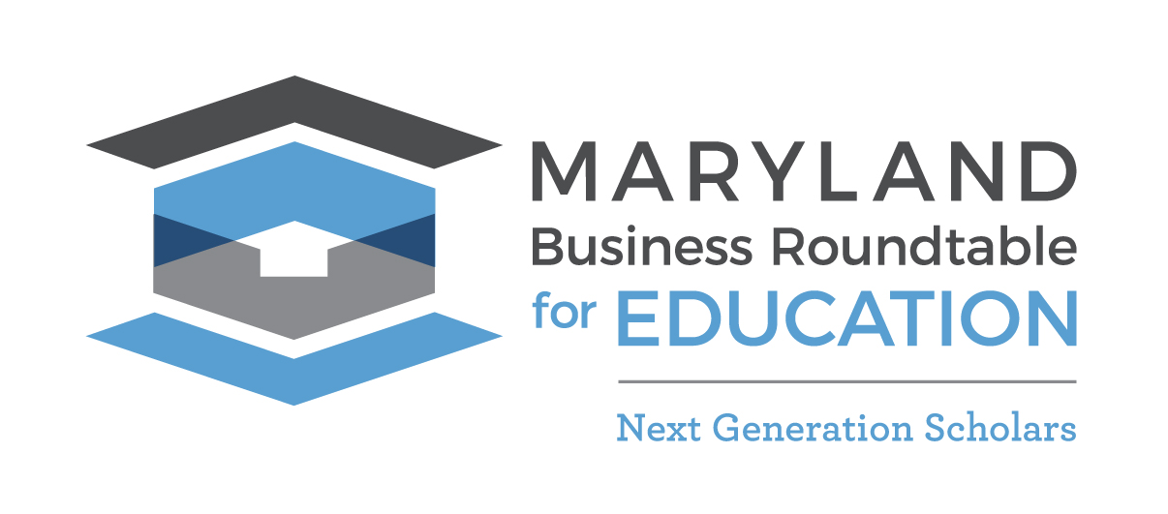 | NEXT GENERATION SCHOLARS “CAREERS CAMP”  ────  HELP WITH APPLICATIONS & RESUMES, GUEST SPEAKERS, PSAT/SAT HELP, GAMES, SOFT SKILLS, & MORE!  ────  JUNE 27th JULY 11th, 18th, 25th plus a BACK-TO-SCHOOL CELEBRATION AUGUST 1ST  INFO: 301-697-3786 or carrie@mbrt.org  FOR: Next Generation Scholars Program students from  Washington Middle School & Fort Hill High School

